Product Qualified Leads: Worksheet

First off, what is a Product Qualified Lead (PQL)?

A product qualified lead (PQL) is a lead who has experienced meaningful value using your product.

If you’re still not 100% sure what a Product Qualified Lead is and how it’s fundamentally different from a traditional Marketing Qualified Lead, please watch this video.

Part 1: Identify Your Product Qualified Leads

Step 1: List Out As Many Potential Value Metrics For Your Business

There are two types of value metrics: functional and outcome-based.

Functional value metrics are “per user” or “per 100 videos.” Pricing scales around a function of usage.

Outcome-based value metrics charge based on an outcome, like how many views a video received or how much money you made your customer.

Here are some common examples of functional value metrics:

- Per contact
- Per user
- Per video

While these are some common examples of outcome based metrics:

- Percentage of every dollar earned
- How many video views
- Cost Per Click (CPC)

Now list out as many potential value metrics as you can think of below.

Value Metric | Type (Function or Outcome-Based)
Per contact | Functional
Cost Per Click | Outcome-Based

Step 2: Stress Test Your Value Metrics

Use the value metric scratch pad to validate which of the value metrics above have potential.

Value Metric Scratch Pad

Condition | True?
It’s easy for the customer to understand.
It’s aligned with the value that the customer receives in the product.
It grows with your customer’s usage of that value.

Continue going through this activity until you have 2-4 value metrics that meet all three of the conditions above.

List the winning value metrics below:

Value Metric:

Step 3: Ask Your Customers

To take this exercise a step further, use a relative preference analysis. This is a simple statistical method to measure value in your product. You force people to make a decision between what they most and least want.

Here’s an example of what it could look like from ProfitWell:

In terms of [company] pricing, which of the following when it comes to pricing is most preferred? Least preferred?

Value Metric | Most Preferred | Least Prefered
Analytics | X
Premium Support
Integrations
SLA
Single Sign-On |  | X

Once you’ve asked enough people, you’ll be able to identify the ideal value metric for your business.

All you need to do is list out your current value metrics that have passed the three conditions above and ask your customers which value metric they least and most prefer.

You can run this survey using survey tools such as Typeform, SurveyMonkey, Google Forms, or even an in-app messaging tool like Intercom or Drift.

Part 2: Create a Seamless Buying Experience

Step 1: Map Out The User Journey

Write down every single step from when a user experiences the value of your product to the moment your user purchases your product.

This could be built out using Trello, sticky notes, or any other tool you see fit.

*For best results, do this activity individually, even if you’re taking this program with your team.
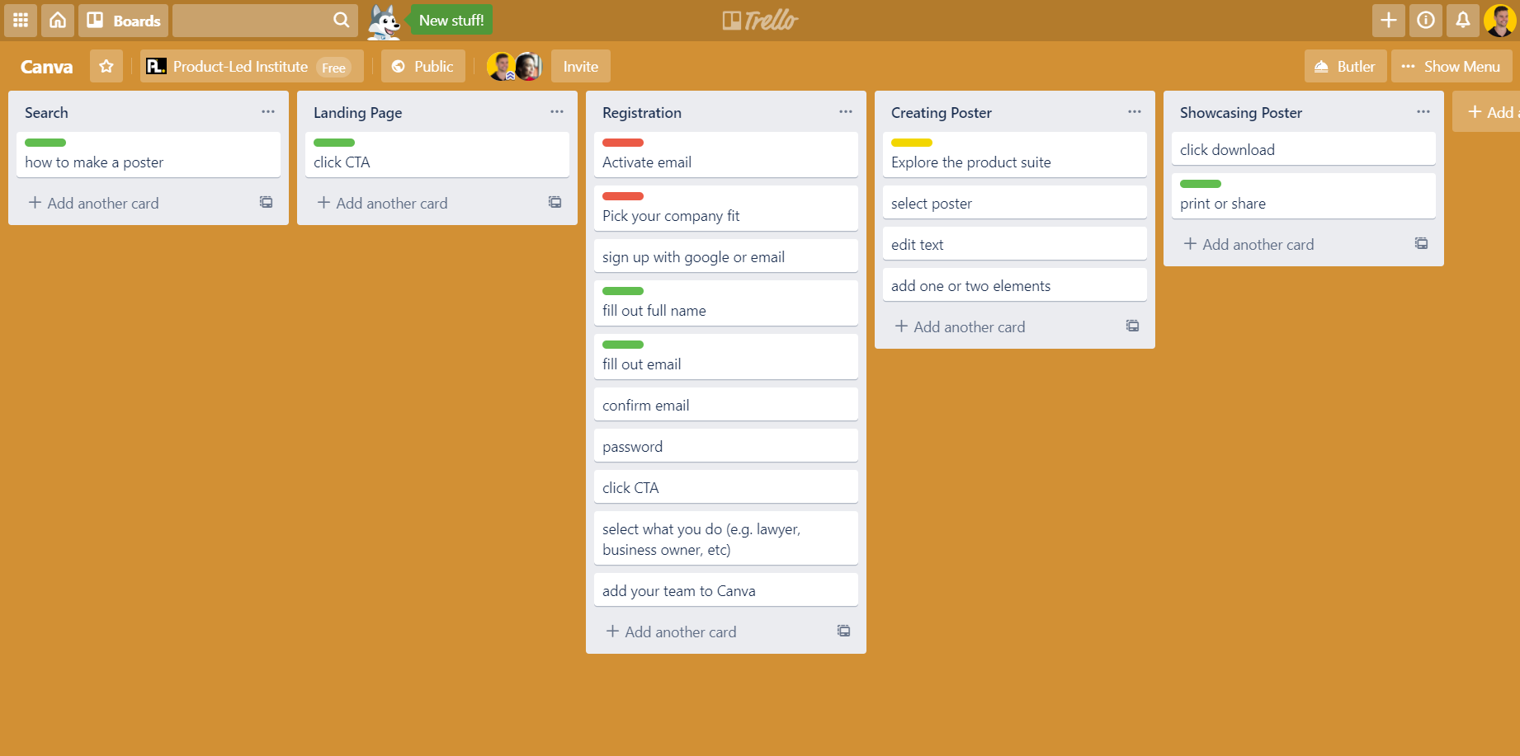

Step 2: Vet Every Step

Once you’ve mapped out your entire onboarding process, ask yourself these three questions:

- What steps can be eliminated? (i.e. Unnecessary form fields & email activation steps)
- What steps can we delay? (i.e. Advanced features)
- What are the mission-critical steps? (i.e. Our product won’t work without this step)

Based on your responses to the questions above, start labelling every step with the colors below:

- Green light indicates that we absolutely must keep the step.
- Yellow light indicates that it’s an advanced step that can be introduced at a later point.
- Red light indicates that a step can be eliminated without hurting the onboarding experience.

*If you’re using posted notes for this process, just use a ✔️ for green lights, ⭐ for yellow lights, and an ❎ for red lights.

Step 3: Develop Your Straight-Line Buying Experience

By now you should know exactly what the mission critical steps are for someone to purchase your product.

But, you’re just basing this off of your opinion. To get the best results, get someone from your product, marketing, sales, engineering, and success team to go through this activity with you.

Have them identify what they deem as unnecessary, advanced, and mission-critical steps. This should get an engaging conversation going as you might not see eye-to-eye on every step which is completely fine. Some steps might be necessary for lots of reasons you weren’t initially aware of. You might also find that you need to add some steps that weren’t initially on the list. That’s fine too!

Your goal is to develop a straight-line buying experience that turns more users into happy, paying customers. Here’s an example of what that might look like:

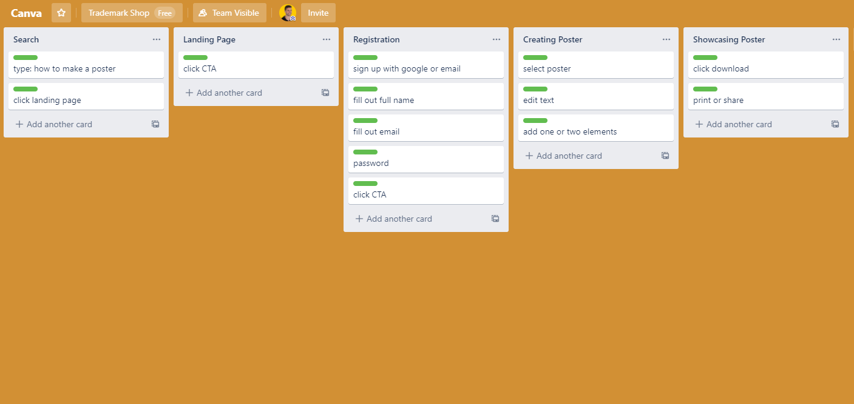

Step 4: Layer on Product & Conversational Bumpers

To further improve your free-to-paid conversion rate, use product and conversational bumpers to create a seamless buying experience.

